Hi,
I have encountered a network error when the kernel booting-up process is complete on a customized board.
The console prints the error as follows:
root@t4240qds:~# fsl_dpa: fsl-dpa: non-zero error counters in fman statistics (sysfs)
Sometimes it will report another error which is:
root@t4240qds:~# fsl_dpa: fsl-dpa: non-zero error counters in fman statistics (sysfs)
fsl_dpa ethernet.18 fm2-mac1: Err FD status = 0x00040000
fsl_dpa ethernet.18 fm2-mac1: Err FD status = 0x00040000
fsl_dpa ethernet.18 fm2-mac1: Err FD status = 0x00040000
fsl_dpa ethernet.18 fm2-mac1: Err FD status = 0x00040000

CPU : T4240 Version 2.0
Kernel : linux-3.12.19 from QorIQ-SDK-V1.6
U-boot: u-boot-2015.01 from QorIQ-SDK-V1.8
FMan: fsl_fman_ucode_t4240_r2.0_106_4_14 from QorIQ-SDK-V1.6
PHY: VSC8488

According to the kernel code(driver/net/Ethernet/freescale/dpa/dpaa_eth.c line 257) comments the error “FM_FD_STAT_ERR_PHYSICAL”
means:
/**< Rx FIFO overflow, FCS error, code error, running disparity
error (SGMII and TBI modes), FIFO parity error. PHY Sequence error, PHY error control character detected. */

In order to locate the error, I added the following code to the end of the function “static void _dpa_rx_error()” (driver/net/Ethernet/freescale/dpa/dpaa_eth.c line 243)
printk("percpu_priv->stats.rx_errors : %lld \n", percpu_priv->stats.rx_errors);
printk("percpu_priv->rx_errors.dme : %lld \n", percpu_priv->rx_errors.dme);
printk("percpu_priv->rx_errors.fpe : %lld \n", percpu_priv->rx_errors.fpe);
printk("percpu_priv->rx_errors.fse : %lld \n", percpu_priv->rx_errors.fse);
printk("percpu_priv->rx_errors.phe : %lld \n", percpu_priv->rx_errors.phe);
And the console prints as follows:
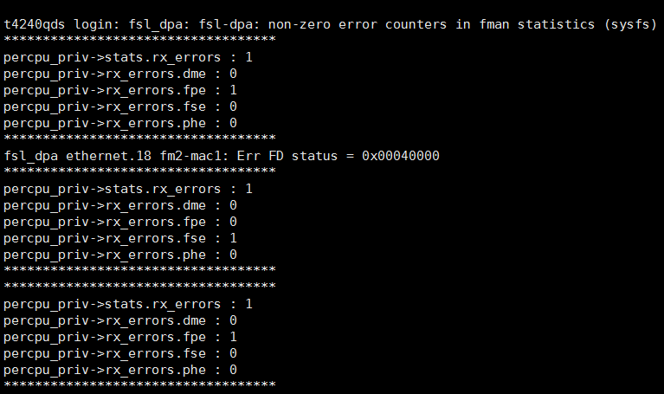

When I tested the speed of the 10GE network through iperf-2.0.5, the number of the error counters continuously increased.
The “ifconfig” command result comes out as:
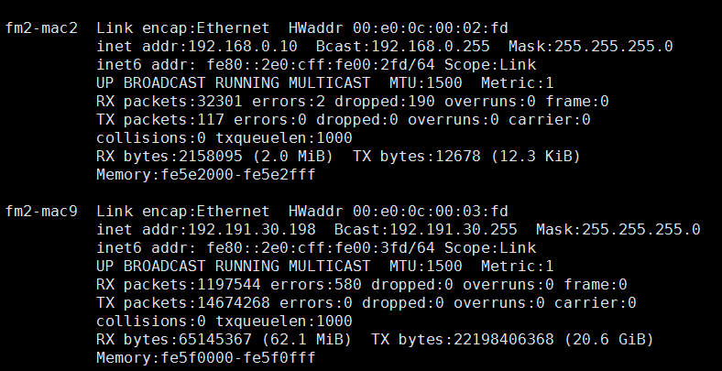
However, the error was not show up when I tested the 1GE network.

I have already done the PRBS31 pattern loopback test on phy(VSC8488), and it works well.

What can I do to fix the error?
Any suggestions would be greatly appreciated!

Have a great day!
Xiao Jun

