The steps to load example code in SDK package for DSC based on CodeWarrior for MCU

- load CodeWarrior for MCU tools
- click File->Import
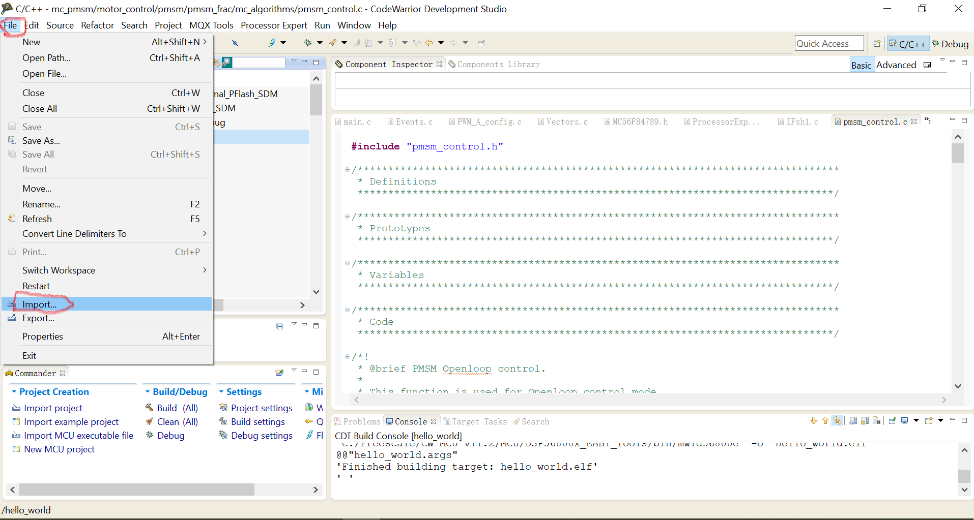

- In the Select menu, click Next
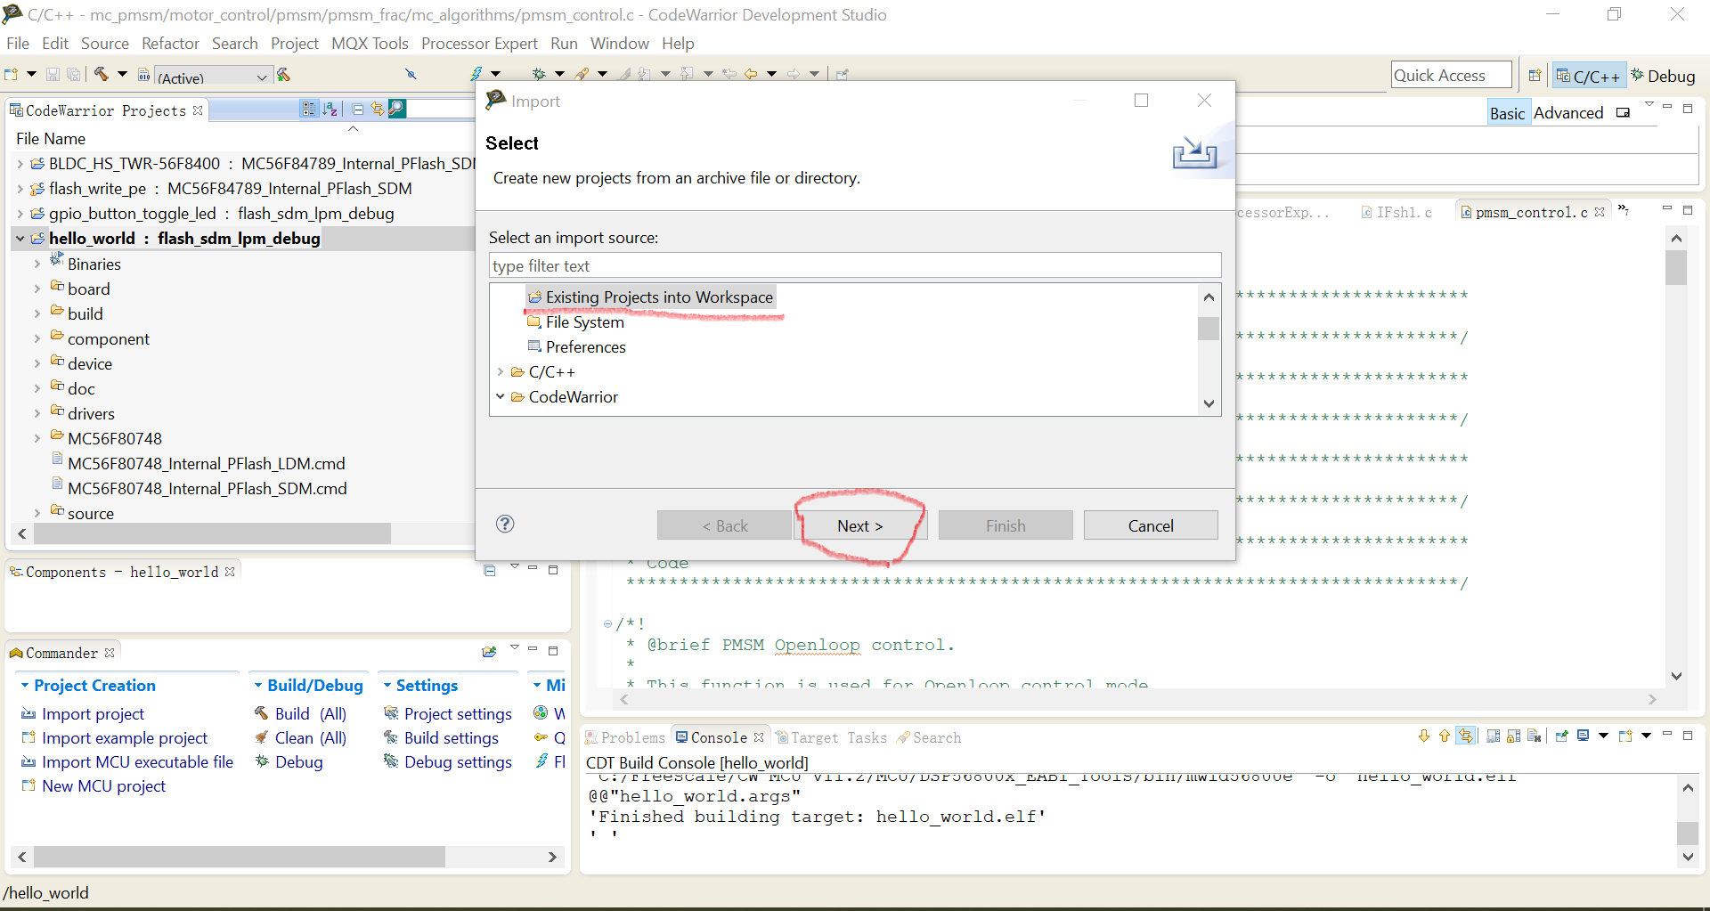

- click Browse to select the example in SDK package
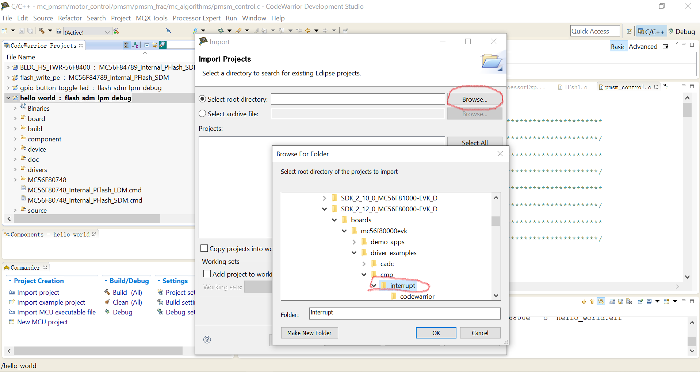

4)click Finish, the example will be loaded into the CW tools
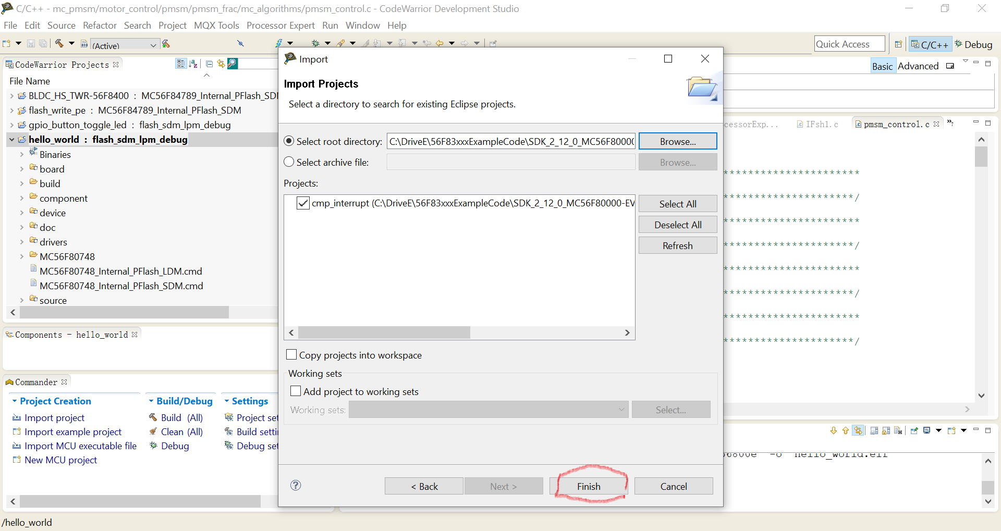

4）load Freemaster example in SDK

