T2081 custom board
Regarding our board from JTAG we have TCK, TMS, TDA, TDI is connected to t2081 processor and Soft reset, hard reset and Target reset is connected to FPGA.
The error I am getting is failed to correctly configure the jtag chain
Running Hello world program:
We are running the program using codewarrior tap and codewarrior ide as follows
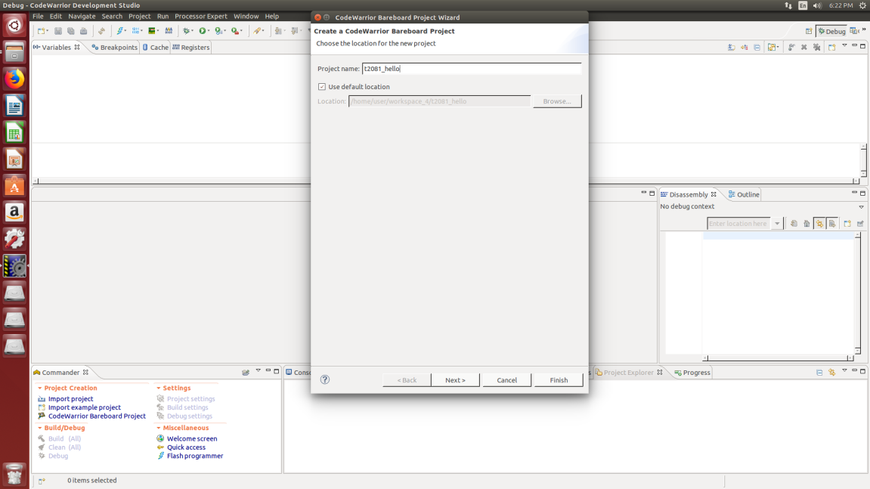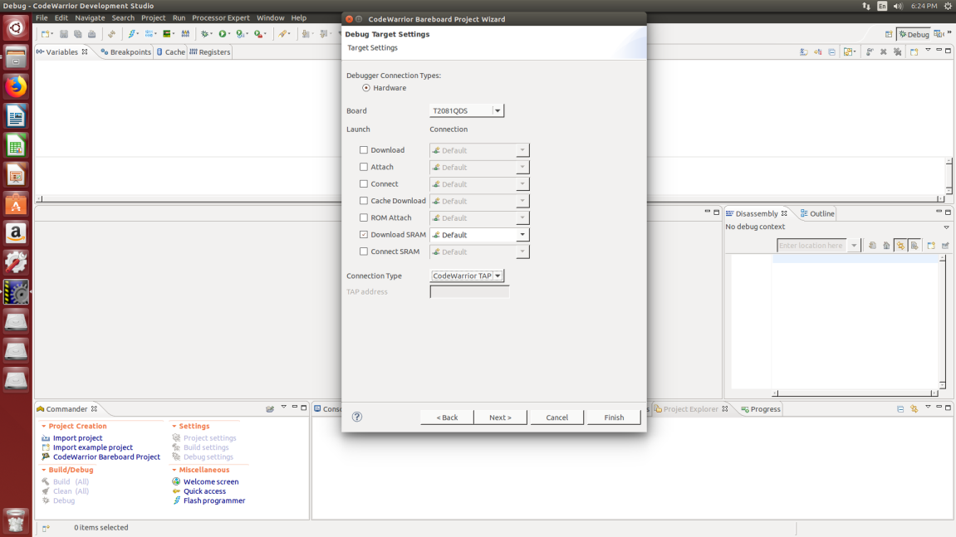

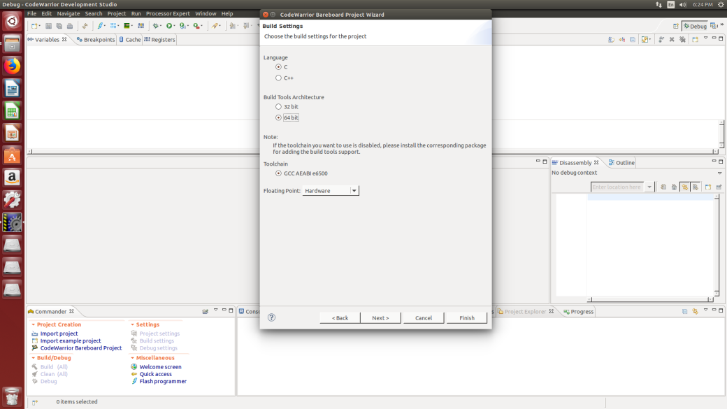
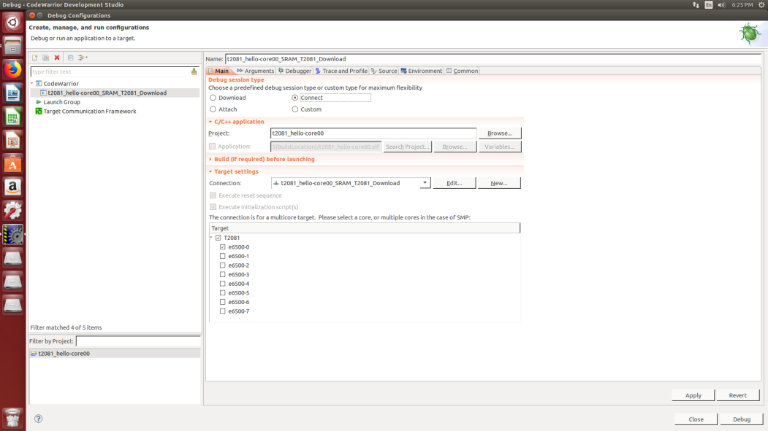
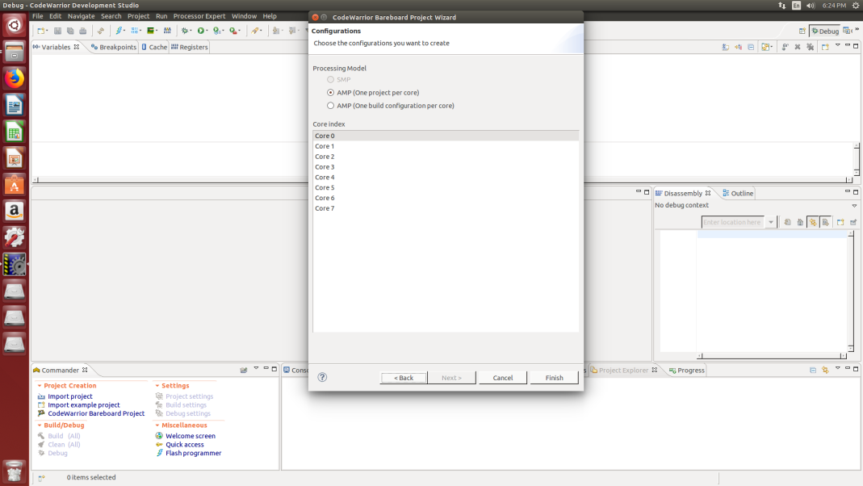
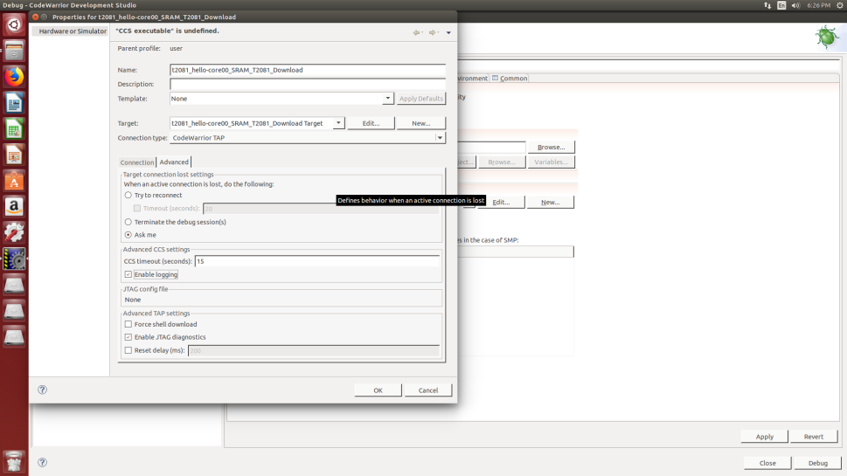
I have also attached the steps on how I am creating rcw below after few steps.
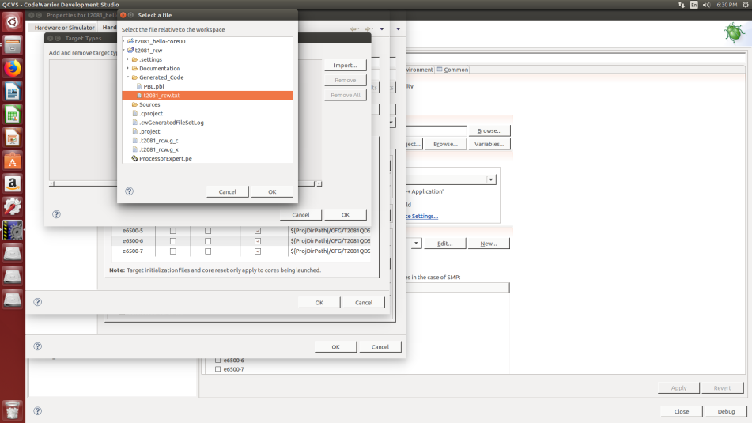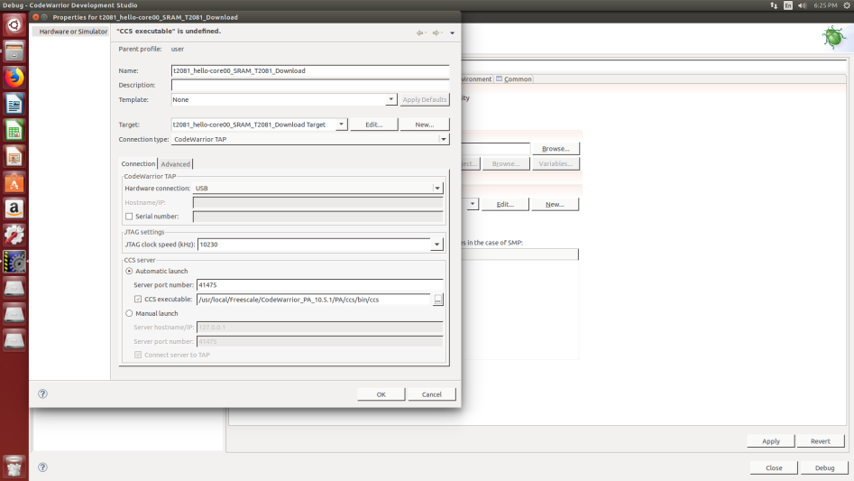
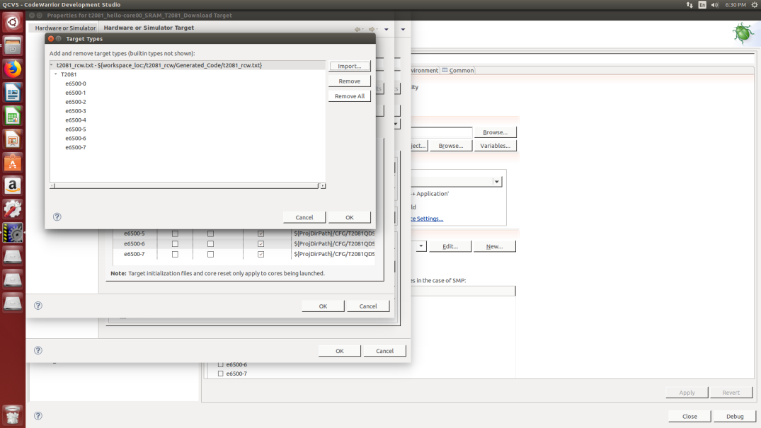
I am getting the same error even I initialize by using sram, ram, download, connect etc.
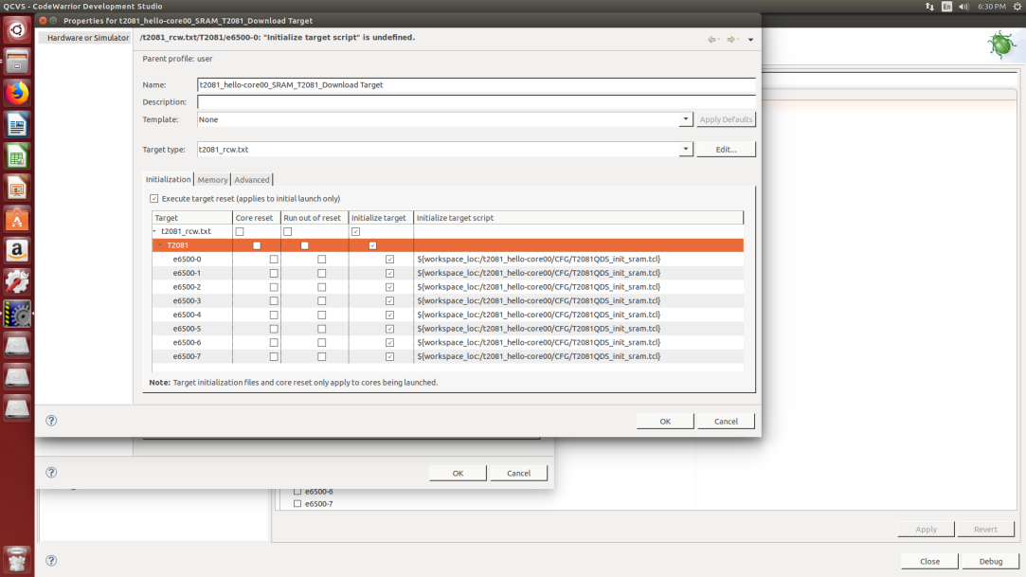
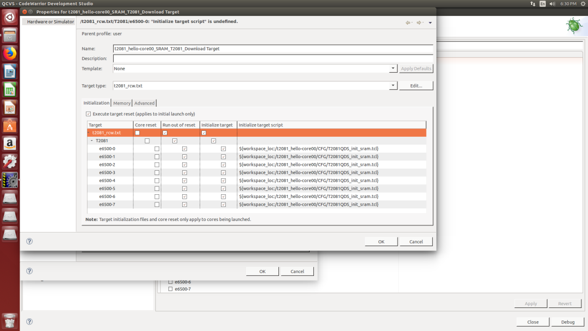
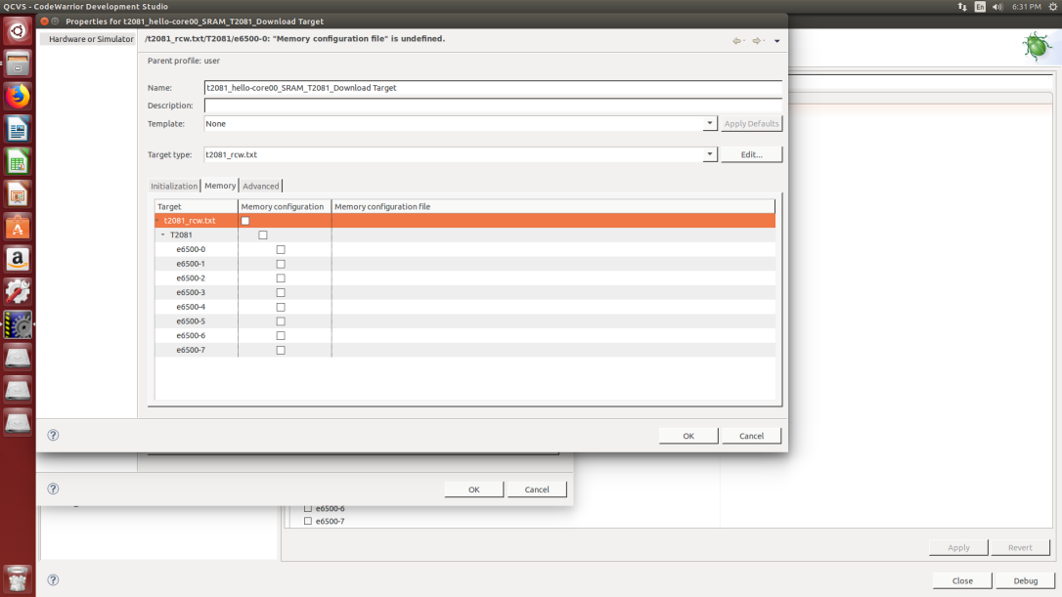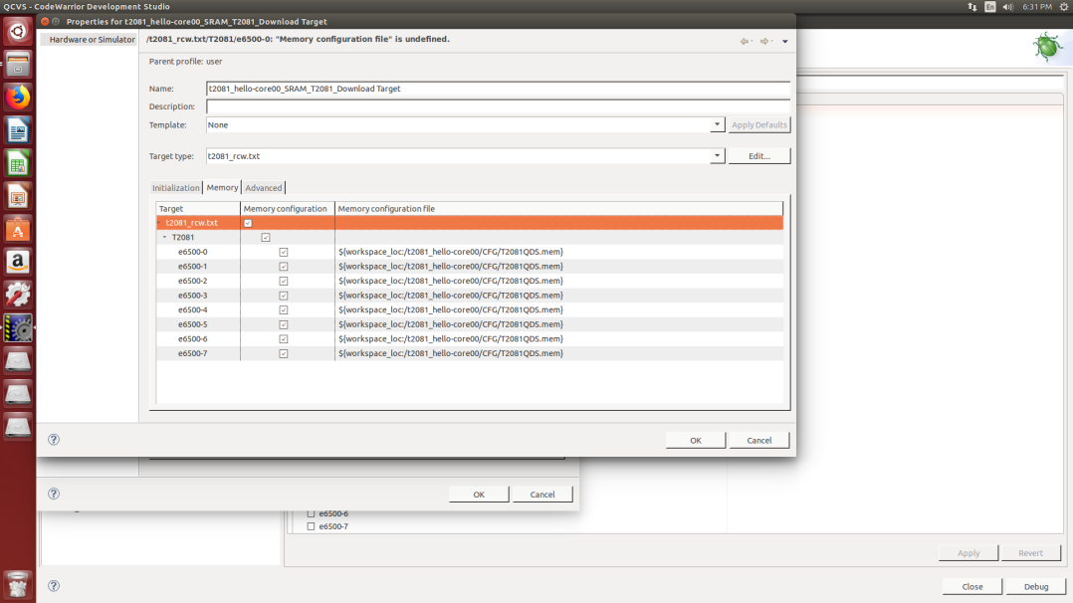
This is the error image.
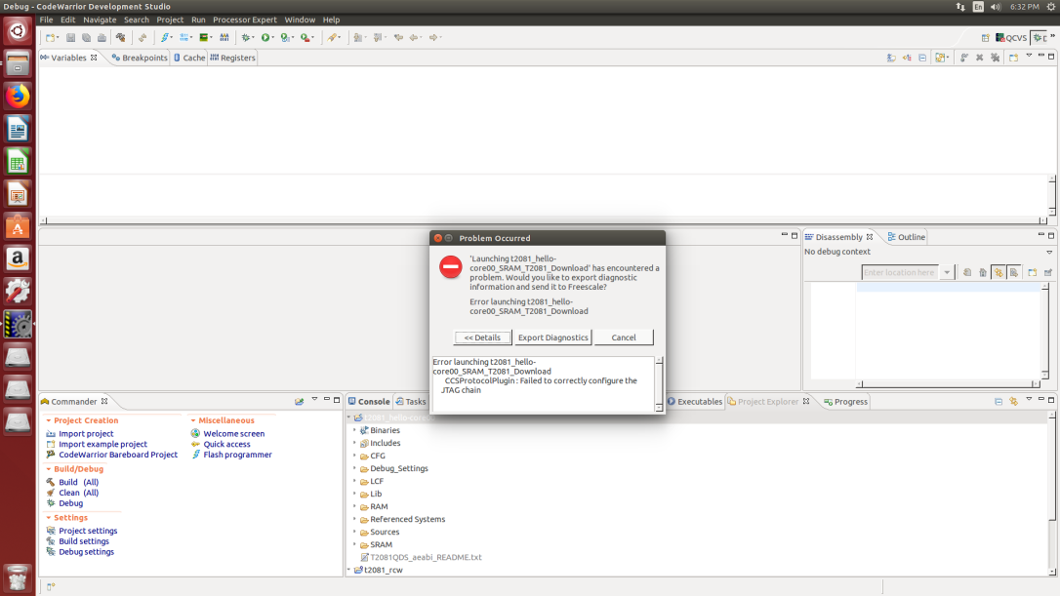

Steps used for creation of default rcw hardcoded options
Also I am getting the same error when creating rcw from t2080rm.pdf 4.6.4.1.2
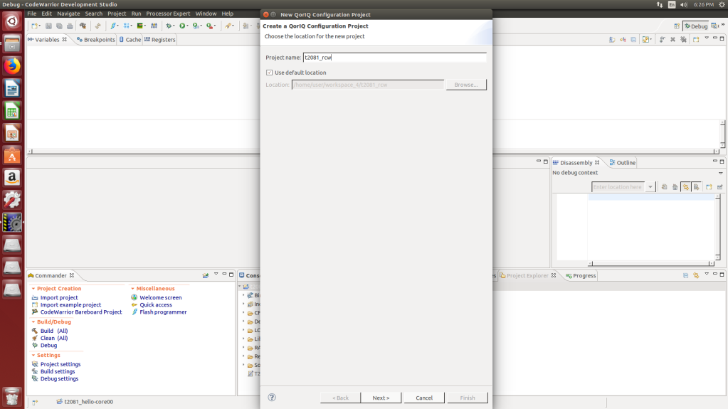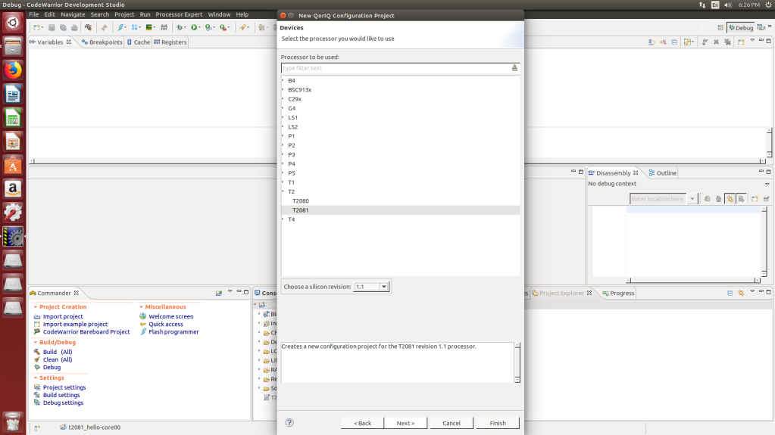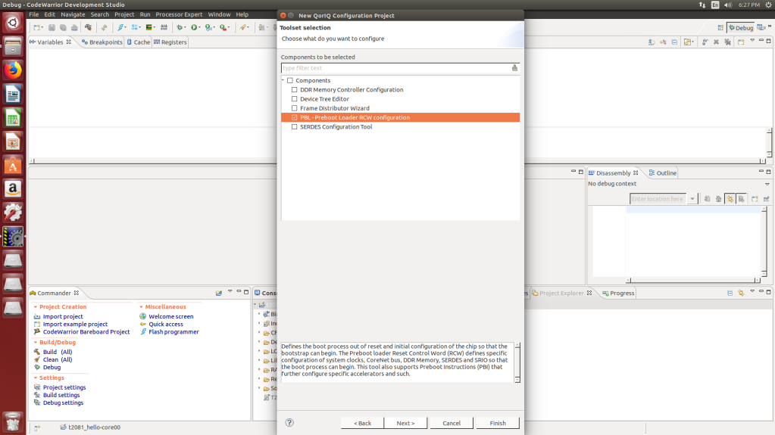
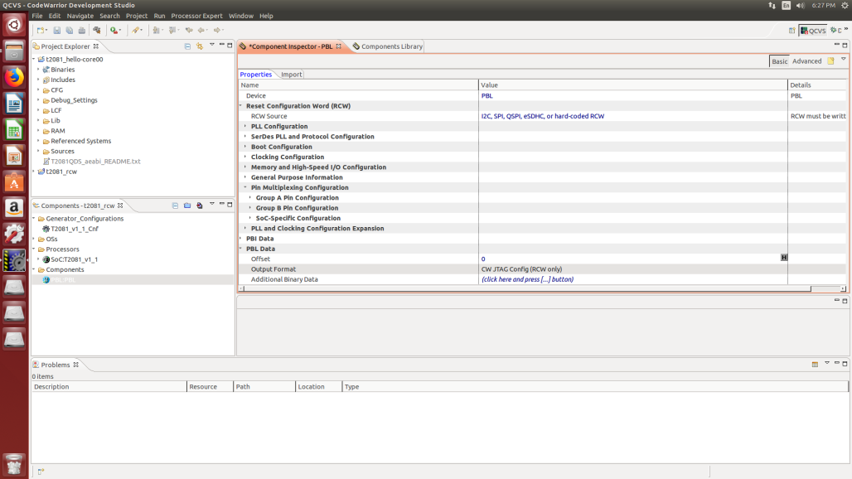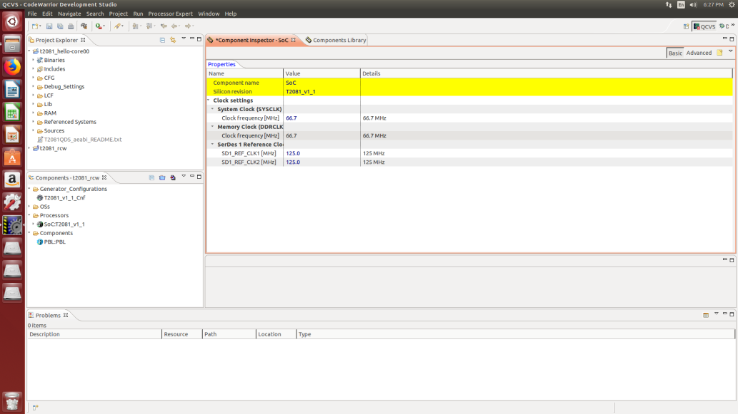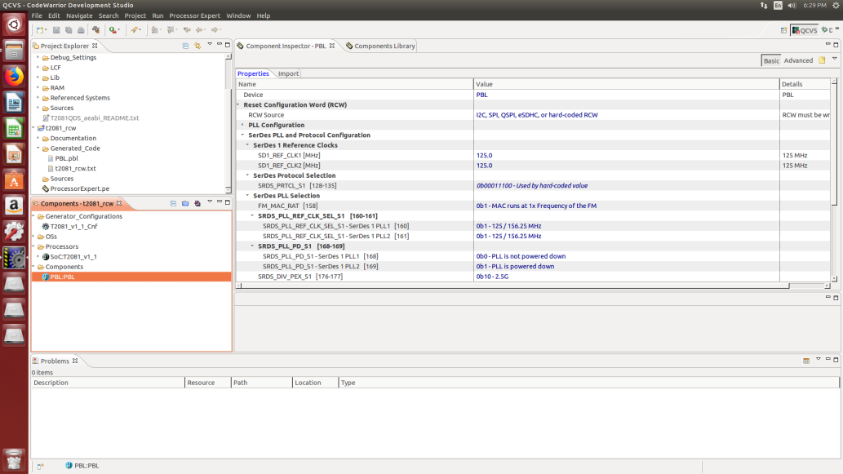

DESIGN OF THE BOARD
NOR FLASH1
256MB

FPGA
T2081
PROCESSOR
NOR FLASH2
256MB
IFC bus Local bus
Multiplexed Demultiplexed
MRAM
256KB

The above picture shows the block level connection between processor and FPGA via multiplexed
The resets from the JTAG are connected to the FPGA .
The logic is
assign proc_jtag_trst = ((flag == 1'b1) ? PORESET : 1'b1 ) & req_rst_r & proc_jtag_trst_n;

assign HRESET_N = ((PORESET) ? req_rst_r : 1'b1) ? 1'b1 : 1'b0;

assign {IFC_AD8 ,IFC_AD9 ,IFC_AD10 ,IFC_AD11 ,IFC_AD12 ,IFC_AD13 ,IFC_AD14 ,IFC_AD15 ,IFC_CLE} = ((req_rst_r & PORESET)== 'b0) ? rcw_hardcoded : 9'bz ; // hardcoded

assign {IFC_AD7,IFC_AD6,IFC_AD5,IFC_AD4,IFC_AD3,IFC_AD2,IFC_AD1,IFC_AD0} = ((req_rst_r & PORESET)== 'b0) ? 8'hff : 8'bz ;
The below picture discloses the output for reset logic implemented in the FPGA.
