Problem statement:
The Flash write fails.

Scenario 1:
Step by step execution (stepover) of the flash write works successfully.
Step 1: Flash init: success
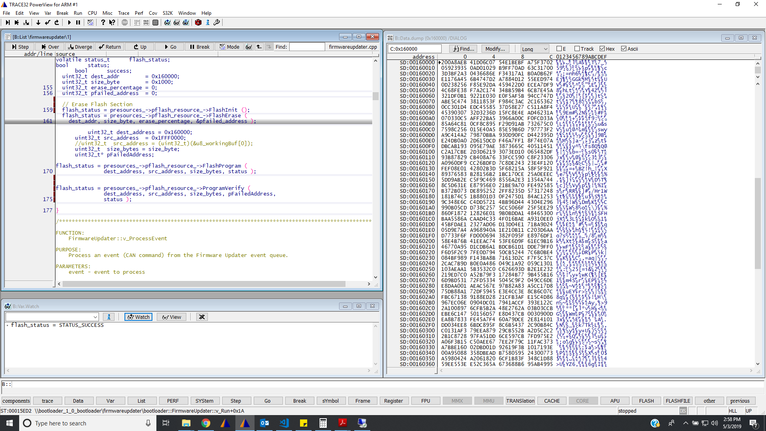

Step 2: flash Erase: Successful

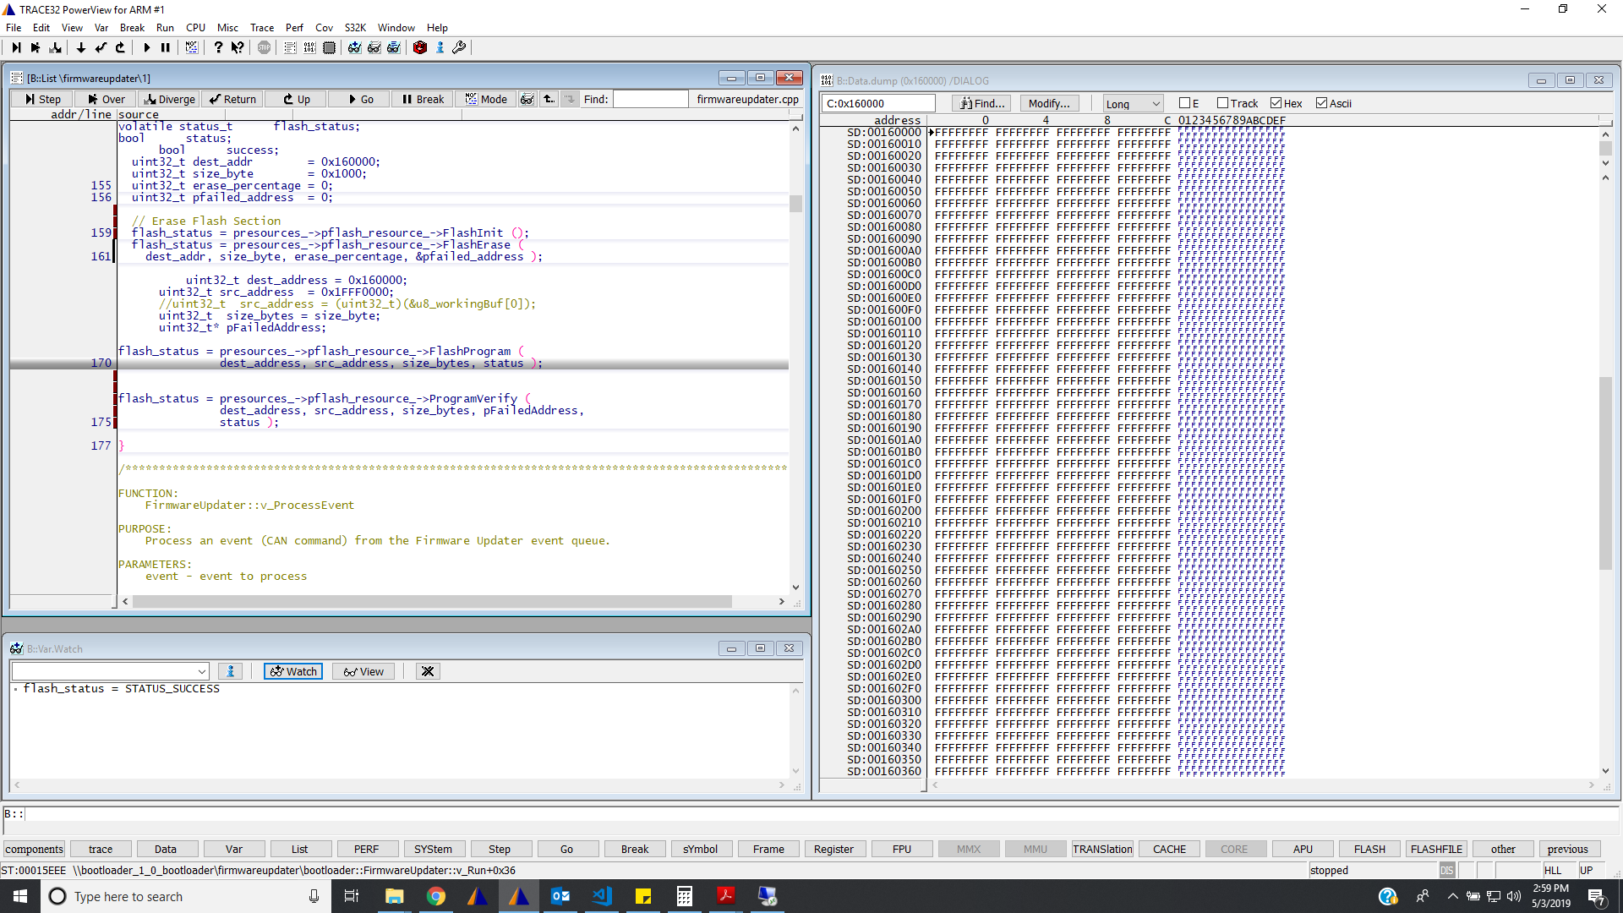

Step 3: Flash Program: Success
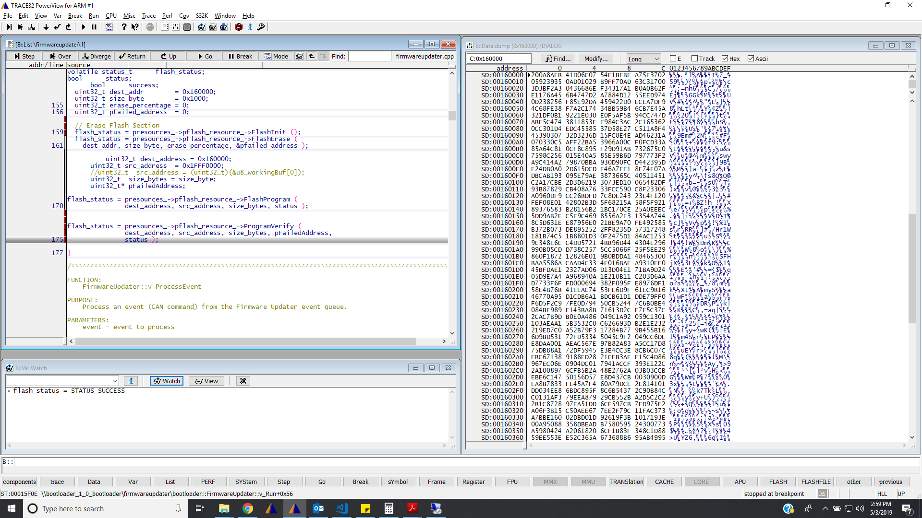

Scenario 2:
All the above 3 steps are executed continuously without breakpoint
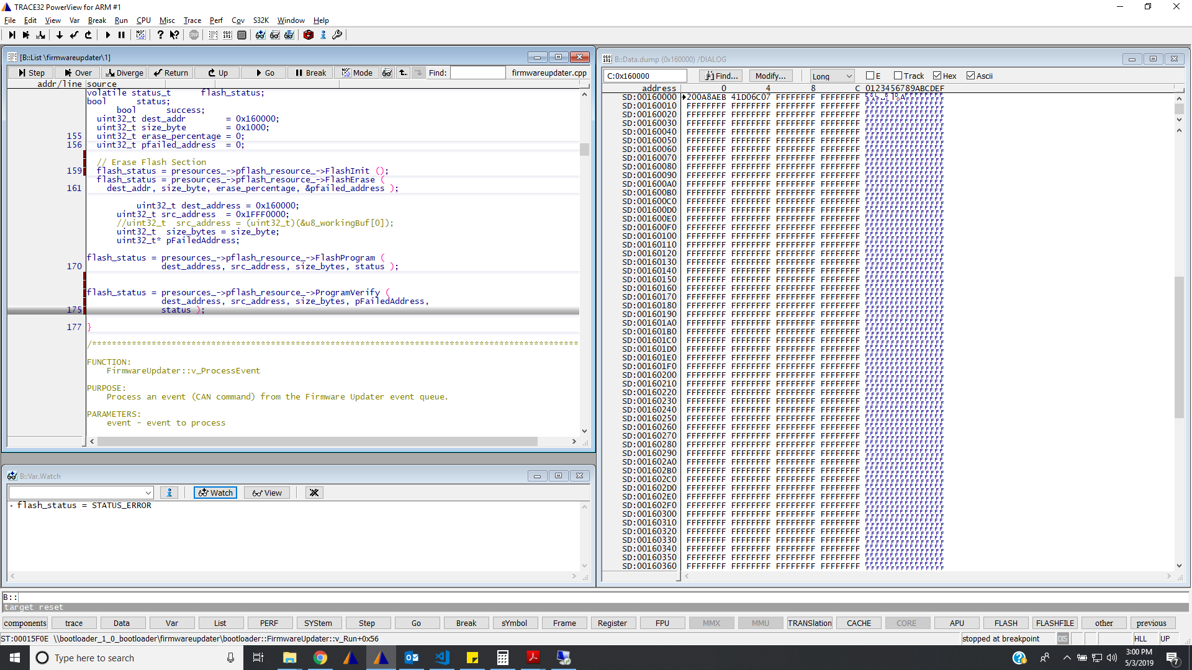

Program flash exited with false (failure) and the data is not completely written to flash.
Scenario 3:
Flash Init and Flash Erase were executed continuously without breaking
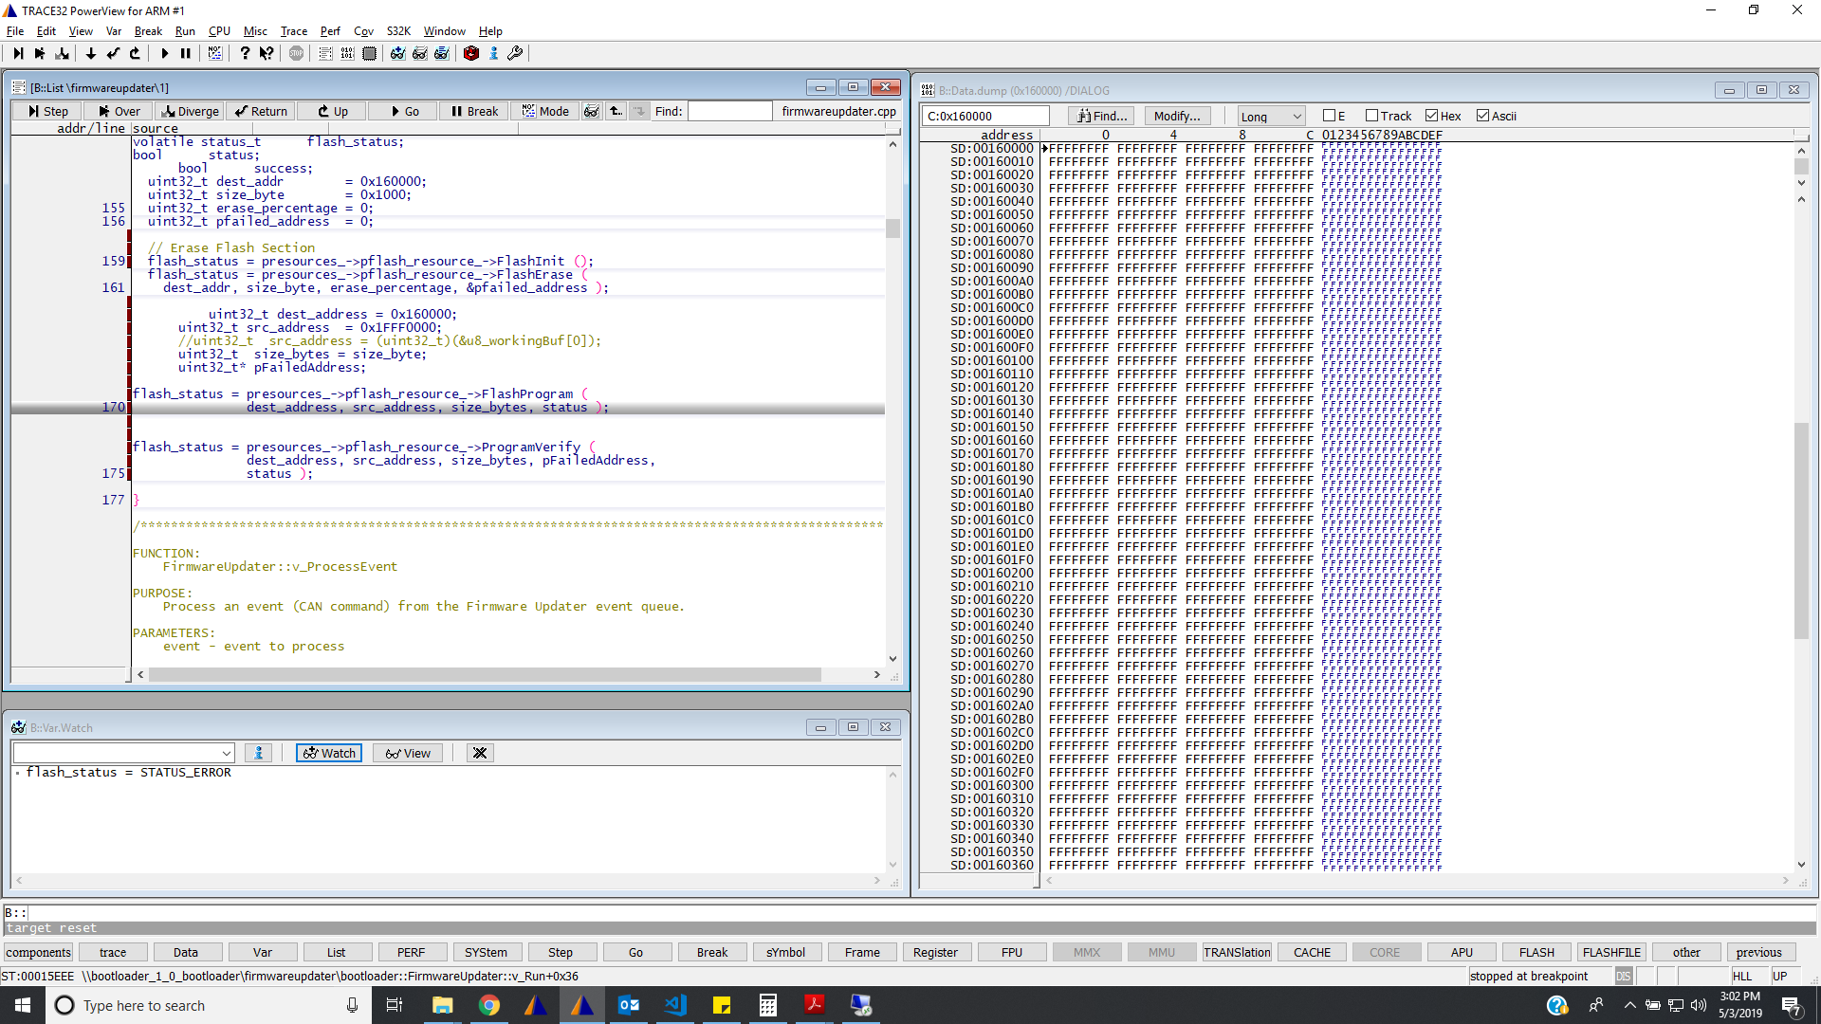

Flash erase failed.

Scenario 4:
Breakpoints at each step:
Flash Init (Success)
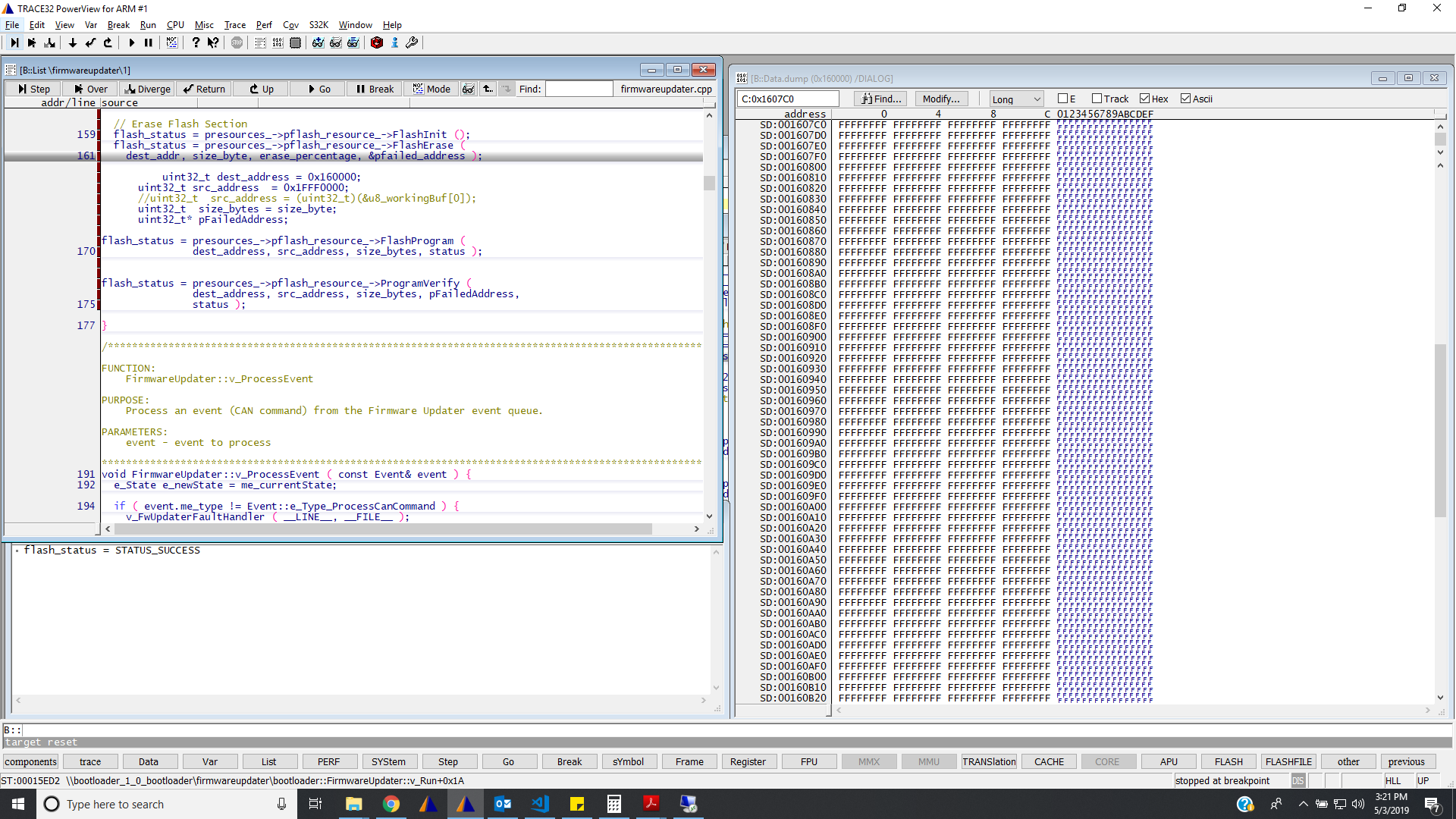
Flash Erase (Failed):
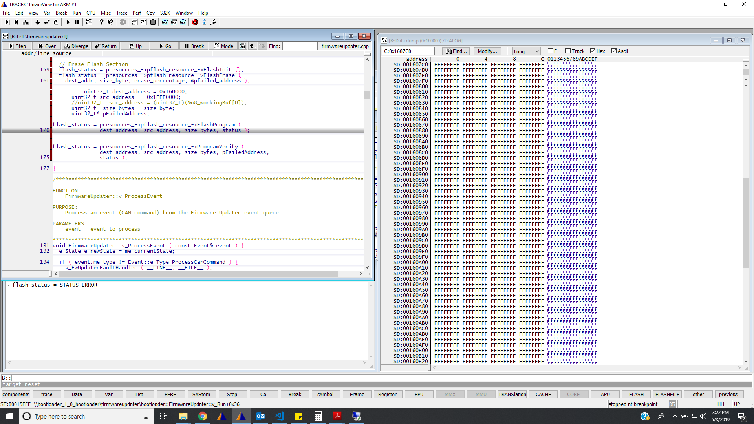

We tested in two different eval board and the observation was same.
Can you please help us.

