Eth General
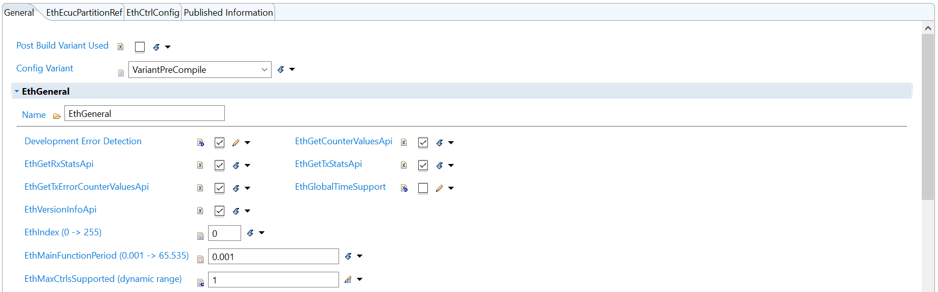
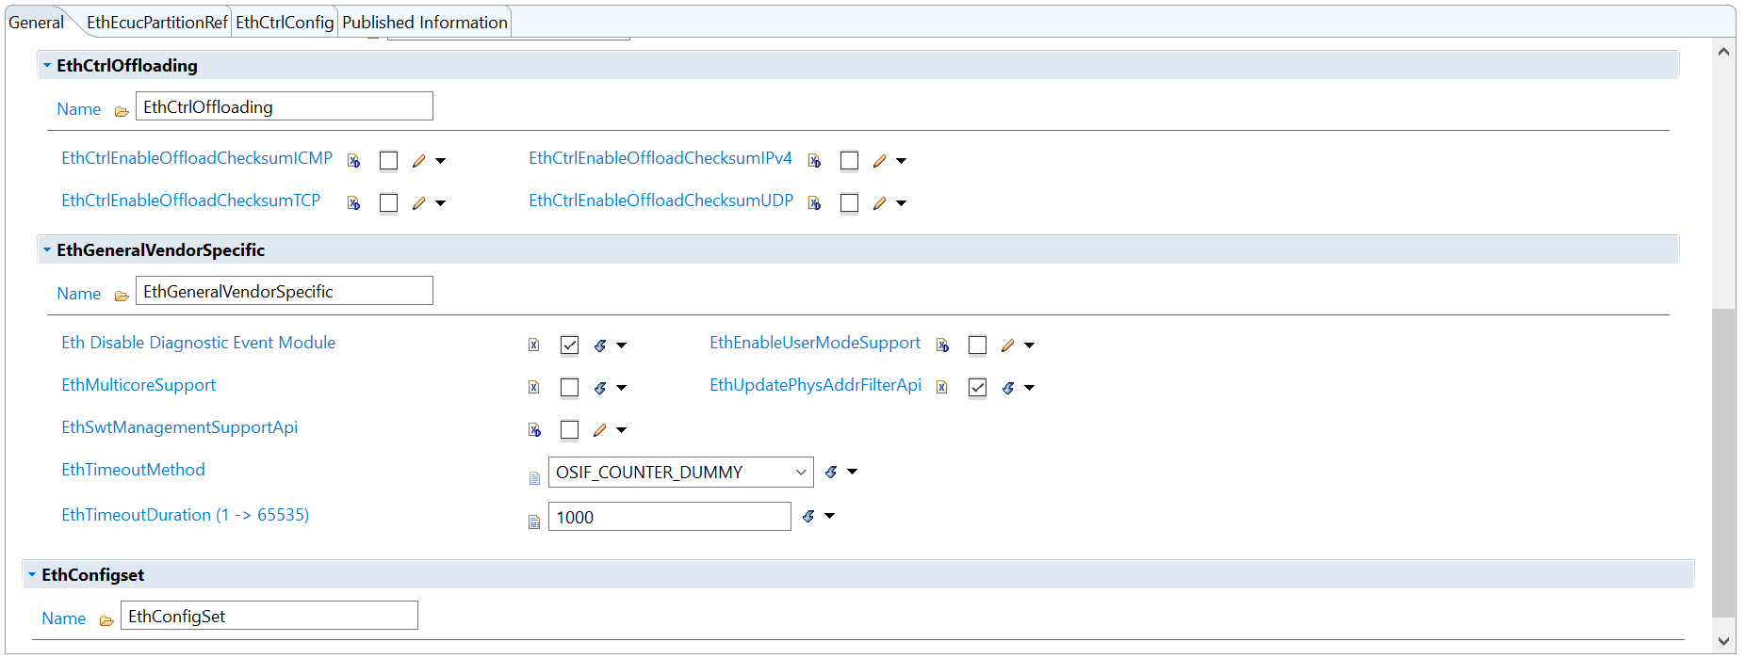

Controller Config
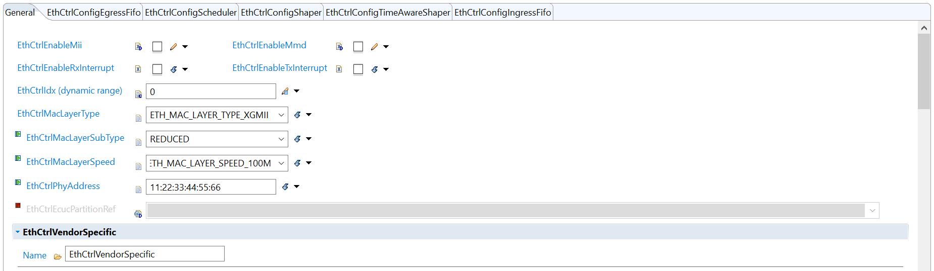
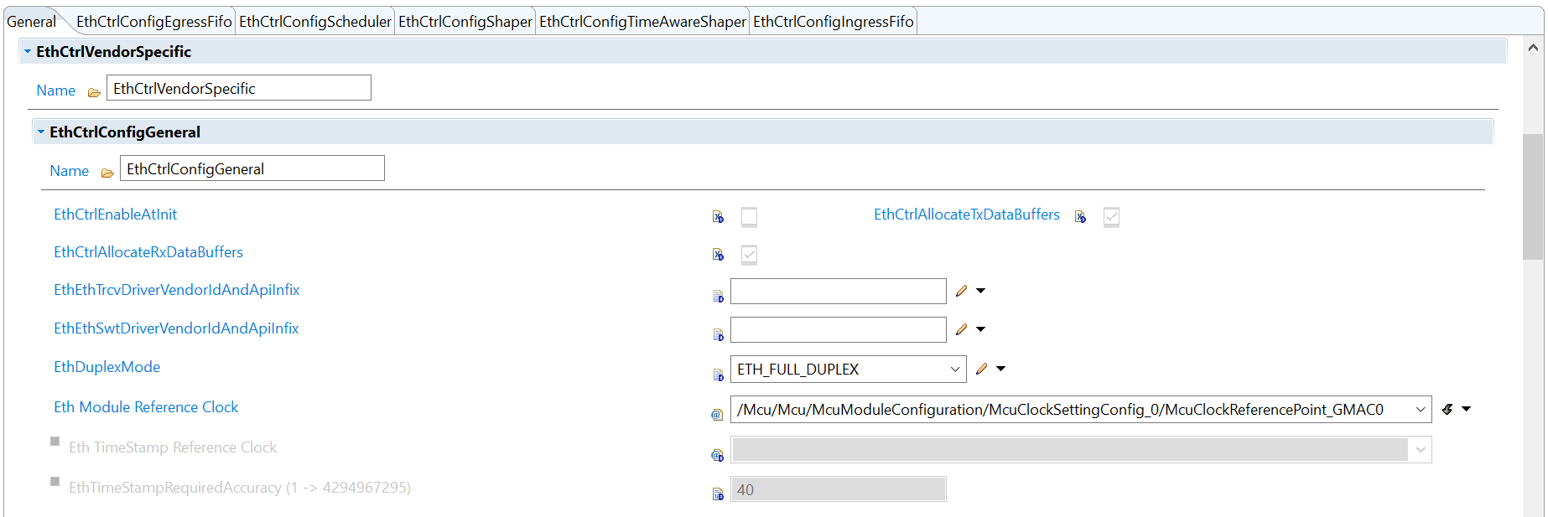
Mcu clock is set to 24MHz custom clock
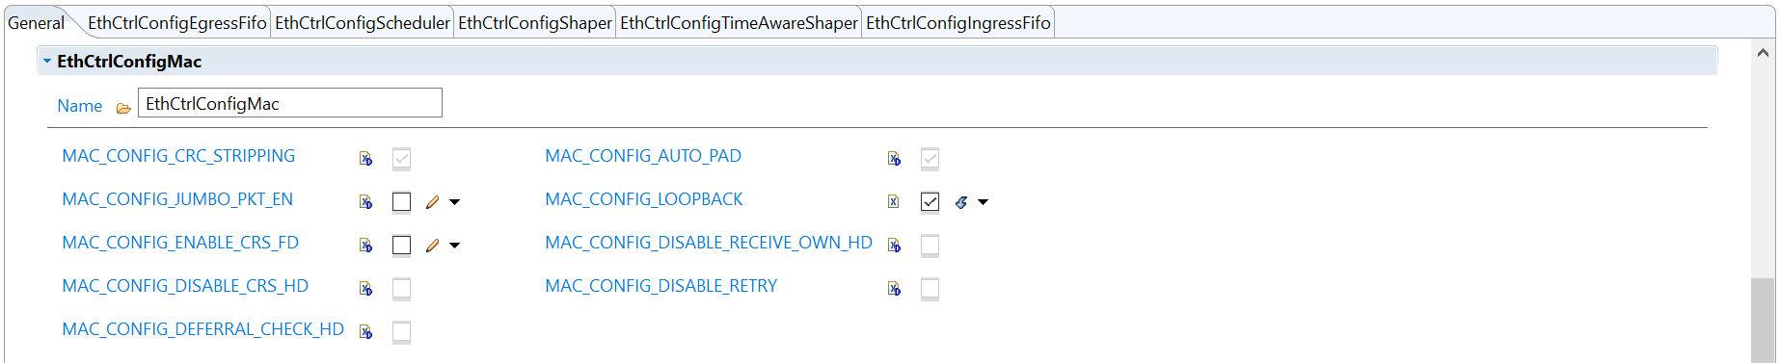
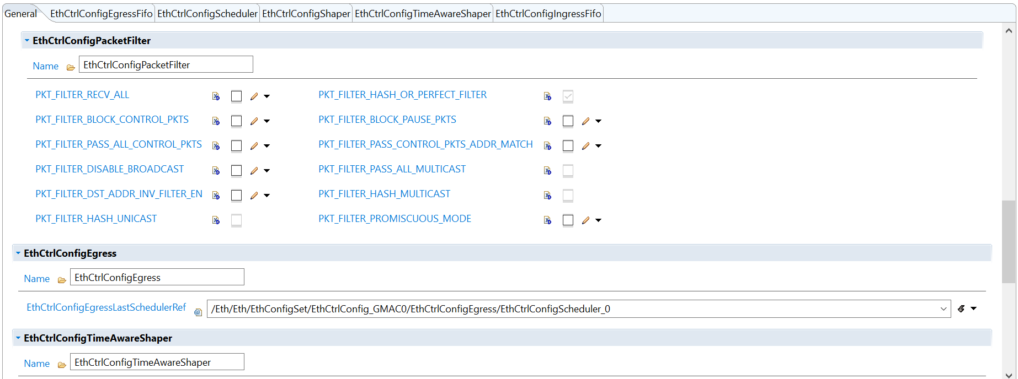
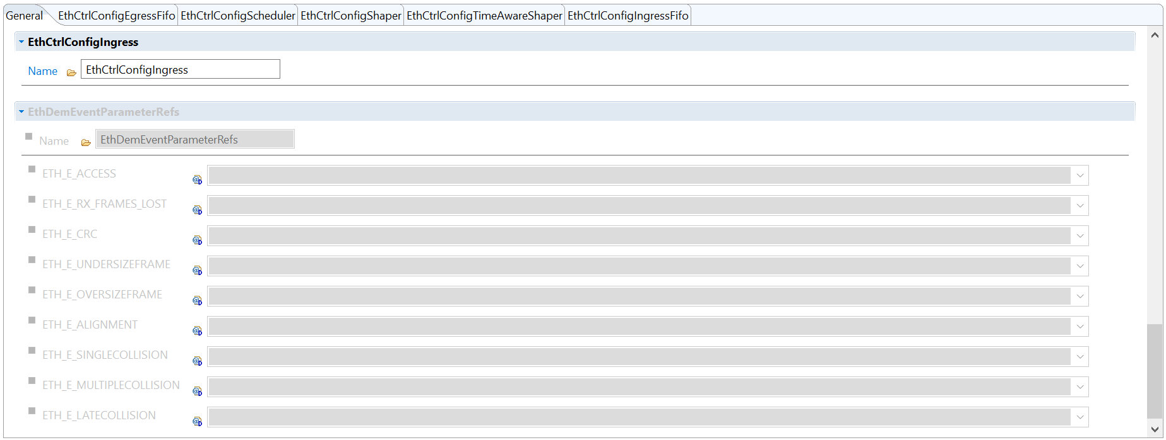

Egress Fifo
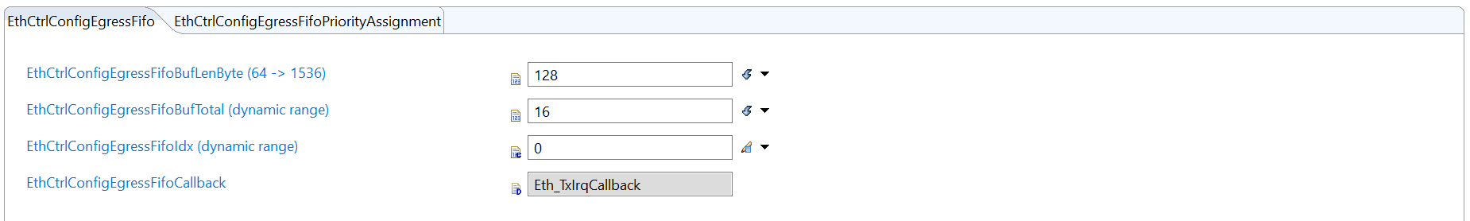
No priority is assigned.

Eth controller scheduler
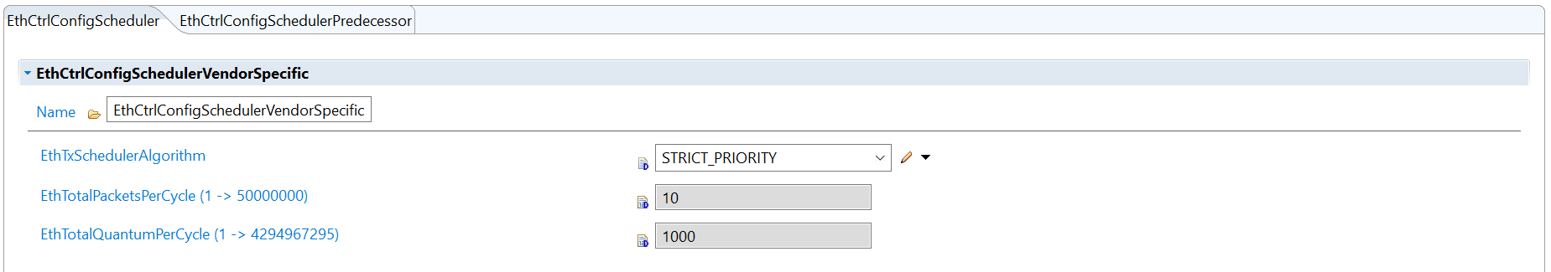
Scheduler predecessor
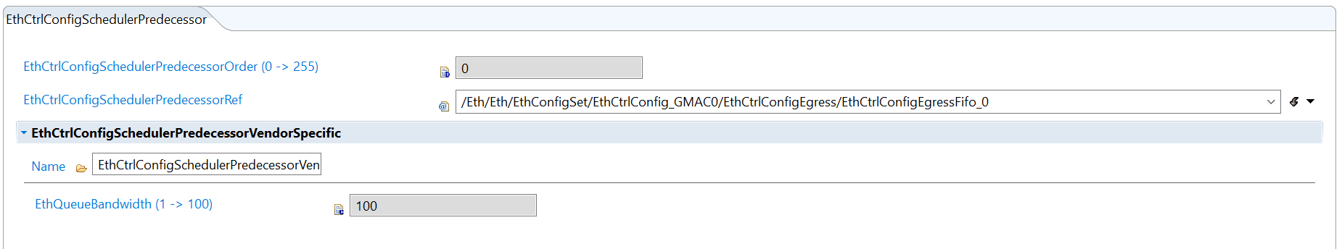
No controller config shaper configured.
No controller timer aware shaper configured.
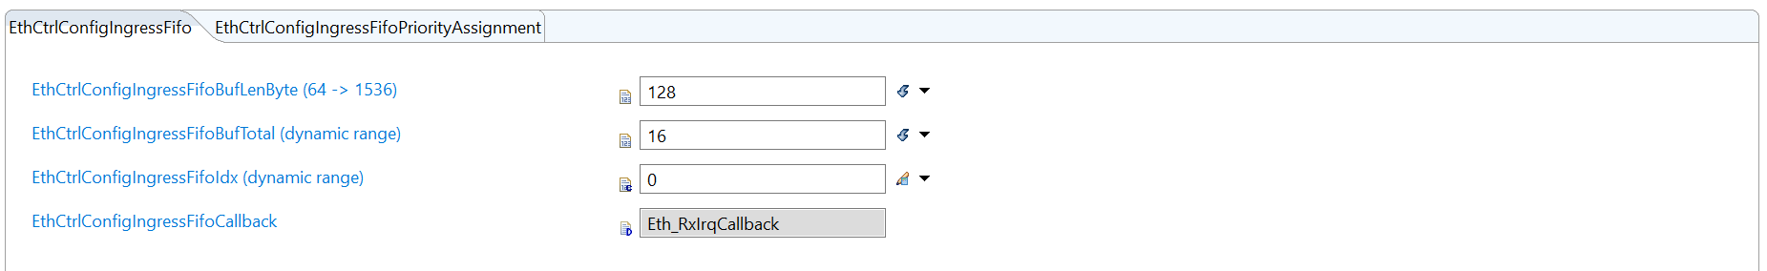
No priority is assigned.

